Thoughts and directions:

1. Change Workforce Connections and WCI verbiage to be consistent – should always read Workforce Connections, Inc.
2. Can the “link buttons” be one of our logo colors instead of blue?
3. Are you able to give us a price quote on the pictures you chose? I need to see in dollar terms to get a better understanding and to be able to get the “go ahead” from Teresa.

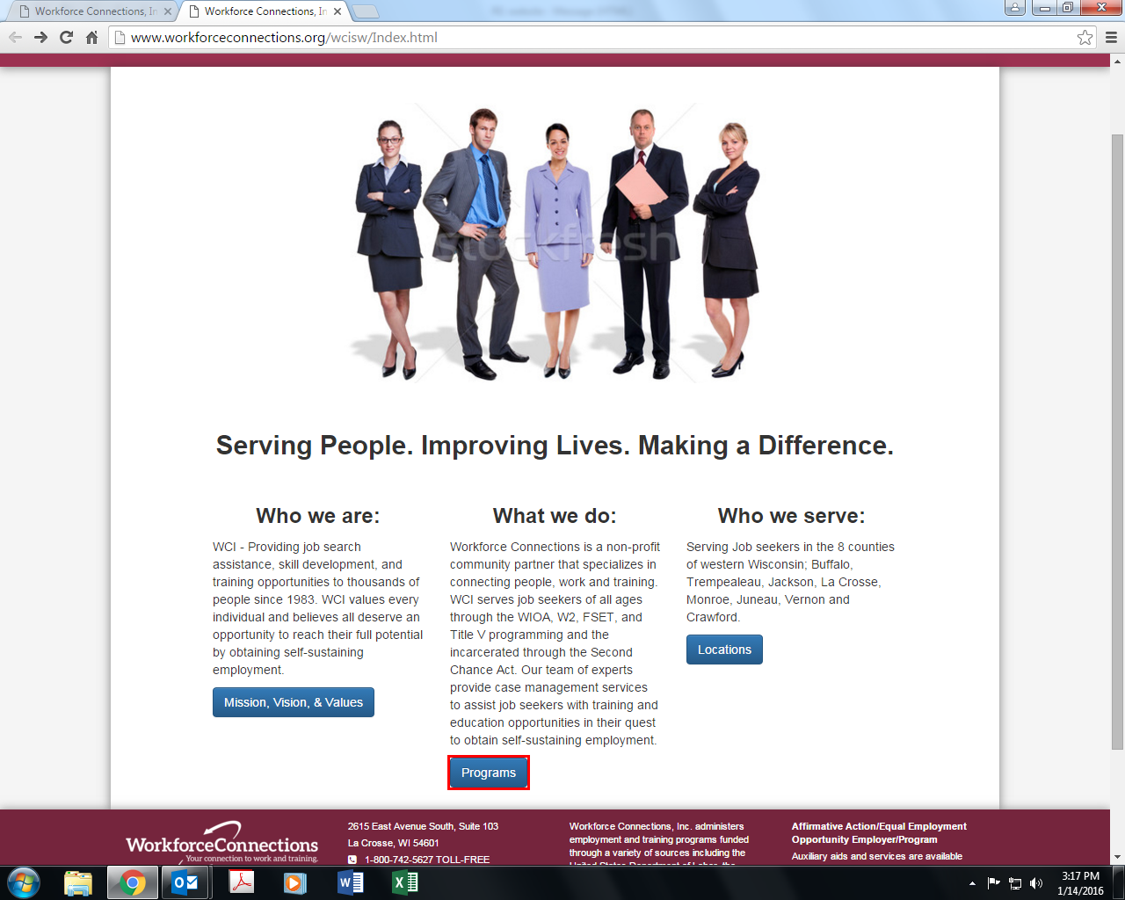

Who we are:

Workforce Connections, Inc. has been providing job search assistance, skill development, and training opportunities to thousands of people since 1983. Workforce Connections, Inc. values every individual and believes all people deserve the opportunity to reach their full potential by obtaining self-sustaining employment.

What we do:

Workforce Connections, Inc. is a non-profit community partner specializing in connecting people, work, and training. Workforce Connections, Inc. serves job seekers of all ages through the WIOA, W2, FSET, and Title V programming and the incarcerated through the Second Chance Act. Our team of experts provide case management services to assist job seekers with training and education opportunities.

Who we serve:

Serving job seekers and businesses from our local offices in the 8 counties of western Wisconsin; Buffalo, Trempealeau, Jackson, La Crosse, Monroe, Juneau, Vernon, and Crawford.



1. Column 2 – Title:

Business Services Specialists

1. Can you put their names and contact information on this page instead of linking to another page? Can you put next to each other to balance out the page?
2. I’m going to ask Carol what other information should be included here. I feel like there should be more here.

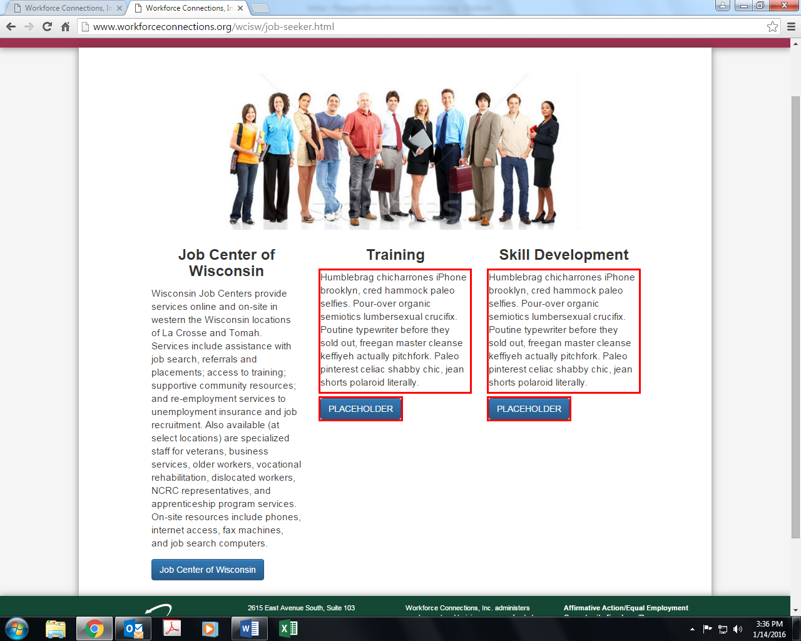

1. Remove Training and Skill Development columns
2. This page will highlight the job center only.
3. Run the text horizontally across the page.
4. Text change:

Wisconsin Job Centers provide services online and on-site in La Crosse and Tomah. Services include assistance with job search, referrals and placements; access to training; community resources; and re-employment services, unemployment insurance and job recruitment. Also available (at select locations) are specialized staff for veterans, business services, older workers, vocational rehabilitation, dislocated workers, NCRC representatives, and apprenticeship program services. On-site resources include phones, internet access, fax machines, and job search computers.

1. Remove blue button and include logo links below the text for Job Center, Indeed.com, Monster, and one for Other resources (which will direct them to the page with the other resources.)

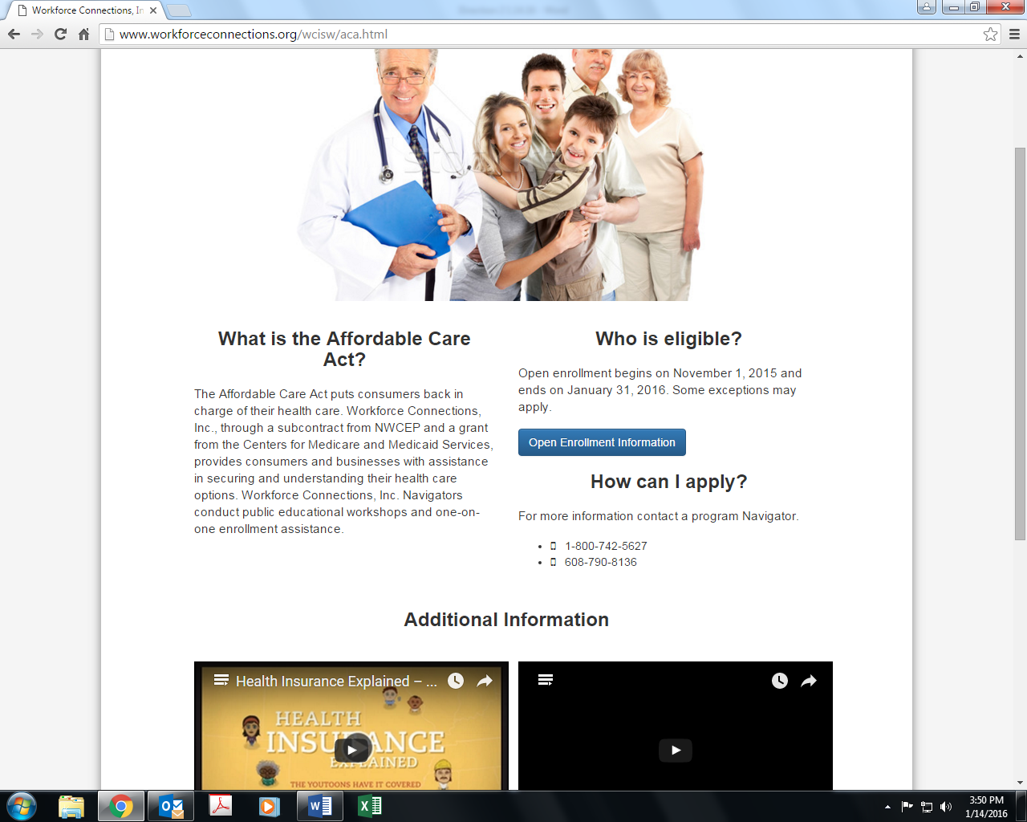

1. Combine eligibility and application sections.

For eligibility and to apply:

Open enrollment begins on November 1, 2015 and ends on January 31, 2016. Some exceptions may apply. For more information contact a program Navigator.

Include phone numbers.

Put Link Button below this information.

1. Remove the words additional information

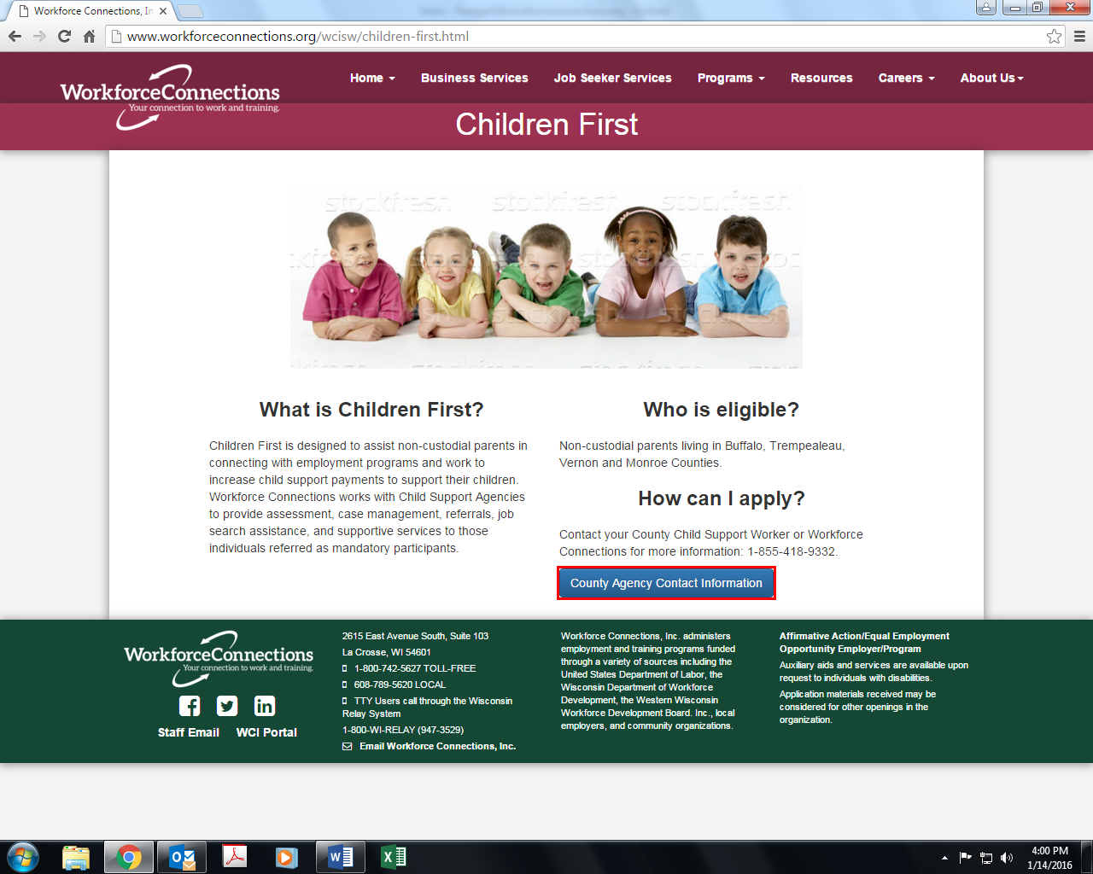

1. Children First is designed to assist non-custodial parents in connecting with employment programs to increase child support payments to support their children. Workforce Connections, Inc. partners with the Child Support Agencies to provide assessment, case management, referrals, job search assistance, and supportive services to agency referrals.
2. Combine column 2 into 1 section:
   1. For eligibility and to apply:

Non-custodial parents living in Buffalo, Trempealeau, Juneau, Vernon and Monroe counties may be eligible. Contact your County Child Support Worker or Workforce Connections, Inc. for more information: 1-855-481-9332.

1. Link Button: Contact Information (see below for link page information)

Buffalo County Child Support Agency

407 S. 2nd St.

Alma, WI 54610

1-608-685-6314

Trempealeau County Child Support Agency

36245 Main St.

Whitehall, WI 54773

1-715-538-2311

Juneau County Child Support Agency

220 E. La Crosse St.

Mauston, WI 53948

1-608-847-9421

Vernon County Child Support Agency

400 Courthouse Square

Viroqua, WI 54665

1-608-637-5335

Crawford County Child Support Agency

220 North Beaumont Road

Prairie Du Chien, WI 53821

1-608-326-0218

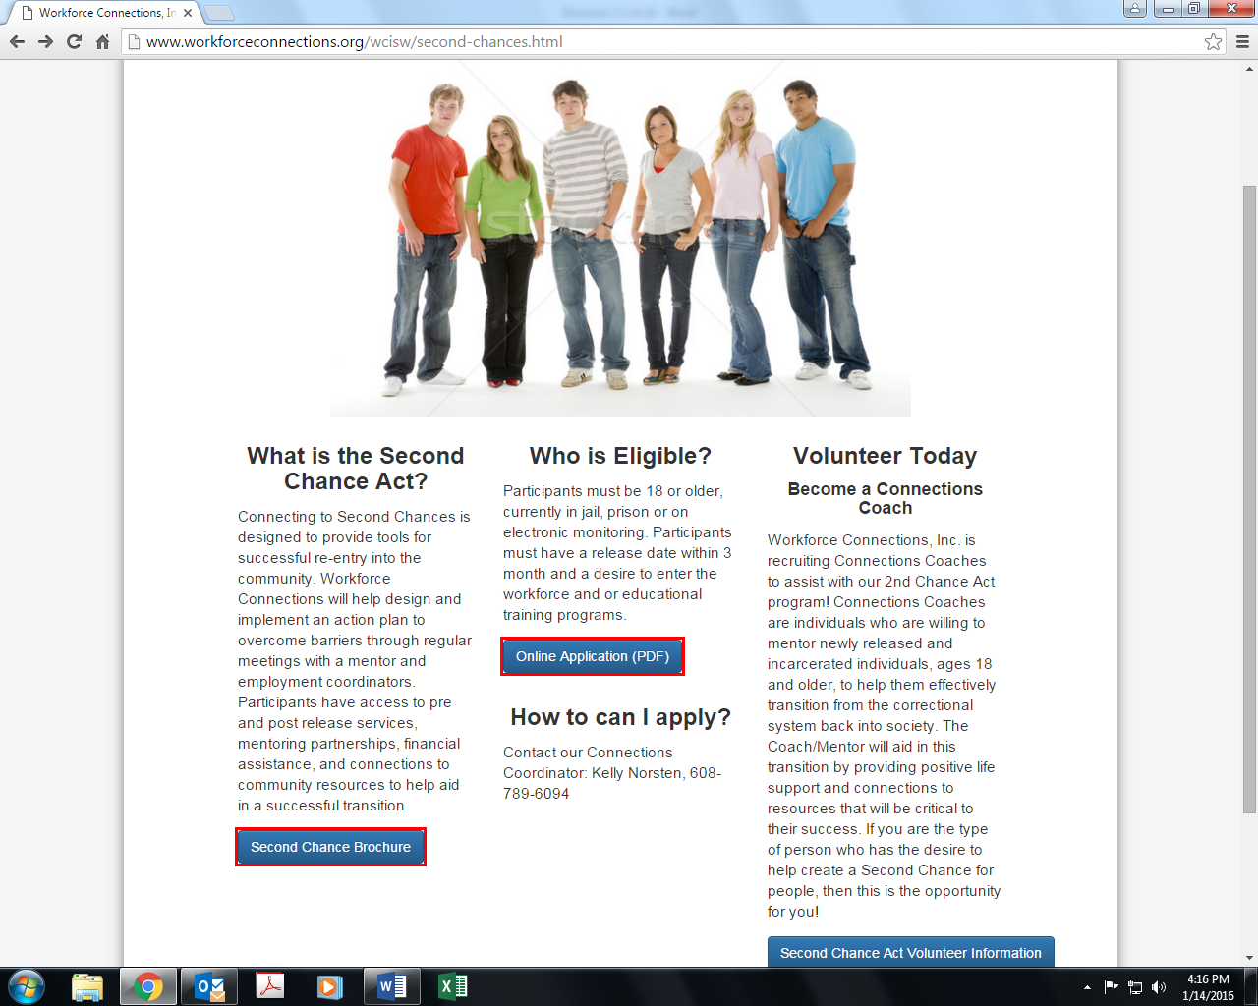

1. 1st column good – change Link Button verbiage: More Information
2. Change middle column: For eligibility and to apply:
   1. Participants must be 18 years of age or older, currently in jail, prison or on electronic monitoring. Participants must have a release date within 3 months of enrollment and a desire to enter the workforce and/or educational training programs. For more information contact our Connections Coordinator; Kelly Norsten, 608-789-6094.
   2. Keep the Application link below this information. Remove (PDF) – or does that need to be there?
3. Volunteer Today
   1. Use the “Become a Connections Coach” as the title for the link at the bottom instead of a subheading.
   2. Workforce Connections, Inc. is recruiting Connections Coaches to assist with our Second Chance Act program. Connections Coaches are individuals who are willing to mentor newly released individuals to help them effectively transition from the correctional system back into society. As a Coach you will provide positive support and connections to resources that will be crucial to their success. If you are the type of person who believes people deserve a Second Chance, then this is the opportunity for you!

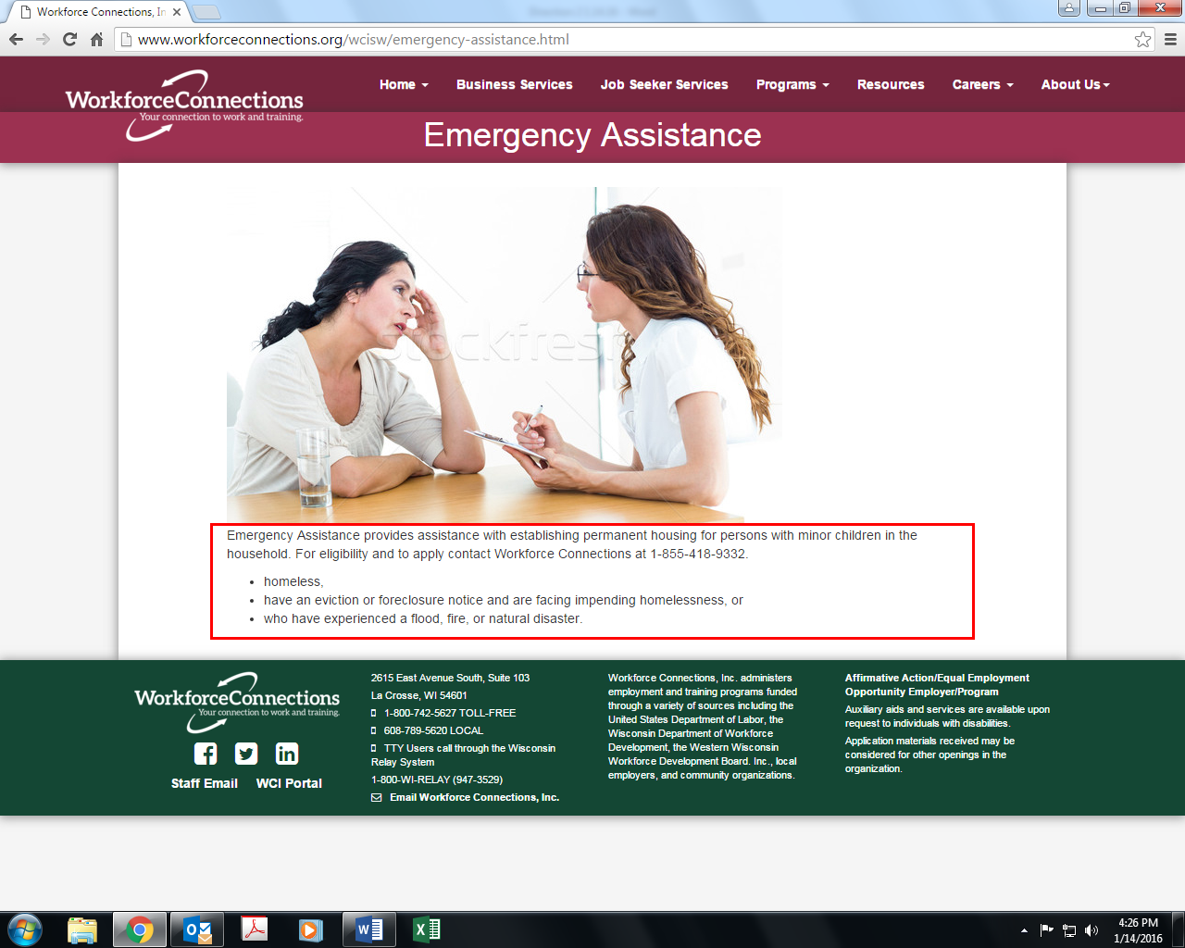

1. Emergency Assistance provides assistance with establishing permanent housing for persons with minor children who are facing homelessness, have an eviction or foreclosure notice or who have experienced a flood, fire, or other natural disaster. For eligibility and to apply contact Workforce Connections, Inc. at 1-855-418-9332.
2. Remove bullets and red box.

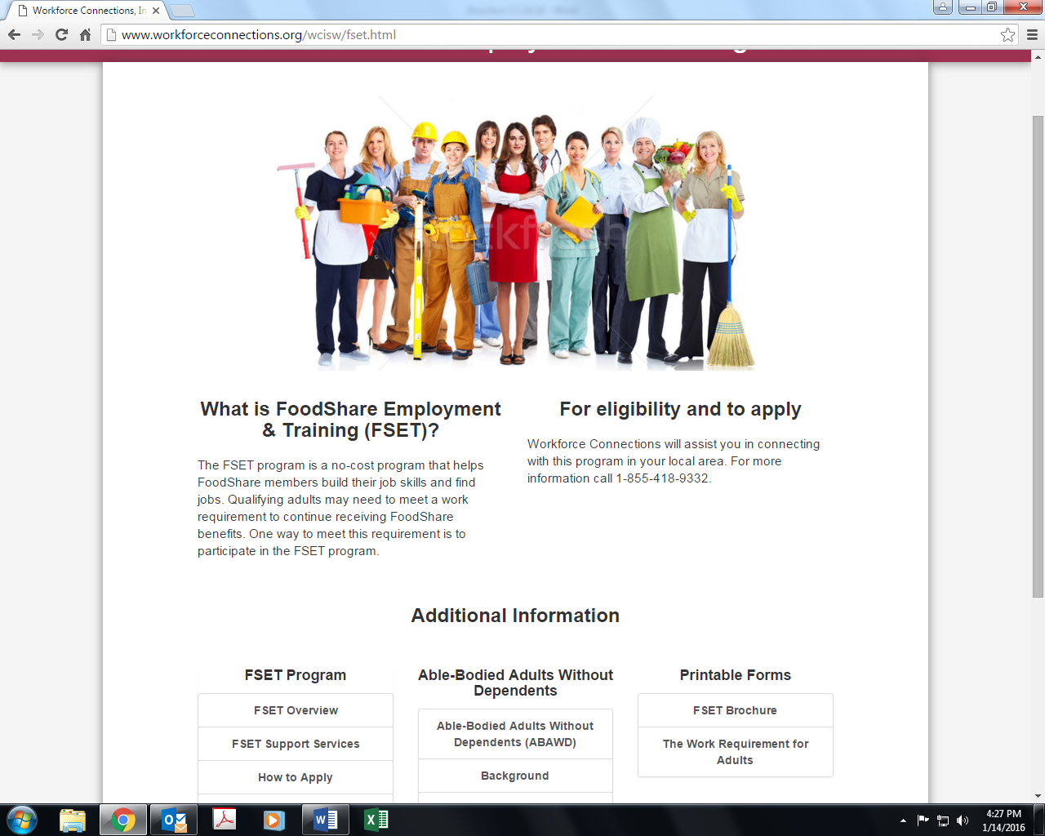

1. The FSET program is a no-cost program that helps Foodshare recipients build their job skills and find employment. Adults needing to meet the work requirement can participate in FSET to continue to receive FoodShare benefits.
2. 2nd column – move the text down to align with first column.
3. Remove “Additional information” and subheadings “FSET Program”, “ABAWD” and “Printable Forms”
4. Modules:
   1. Get Rid of How to apply, this is redundant
   2. Combine the first four “links” in second column for ABAWD into to one module to read as follows:

What is ABAWD?

ABAWD stands for “Able-Bodied Adults Without Dependents”. This is a federally-mandated policy within the SNAP (Supplemental Nutrition Assistance Program) or FoodShare program. The following is a brief summary of the ABAWD policies. For more specific information on ABAWD requirements, please contact an eligibility worker through your Income Maintenance Consortium.

The ABAWD policy is part of FoodShare and applies to some FoodShare recipients. It was first enacted with the passage of the PRWORA legislation in 1996. As a national program, states are required to apply time-limited benefit policies for ABAWDs. But many states, including Wisconsin, were able to receive a waiver from applying the ABAWD rules because of high unemployment.

Wisconsin applied the ABAWD policies from 1998 - 2002. Wisconsin received a waiver beginning in 2002 due to our unemployment rate. The policy was re-implemented state-wide beginning on 4/1/15.

An ABAWD is a FoodShare recipient who meets all of the following conditions:

Is between 18 – 49 years old; and

* Is able to work; and
* Is not residing in a FoodShare household with a child under age 18 (child must be a member of the Food Unit even if the child is not eligible for FS); and
* Is not pregnant

A FoodShare recipient who is subject to the ABAWD policy (and does not have an exemption), can continue to receive FoodShare benefits, but is limited to only receiving benefits for three months without meeting the work participation requirement during a 36-month period.

If a recipient, who is subject to the ABAWD policy, meets the work requirement for a month, that month does not count towards the three month limit. When an ABAWD recipient does not meet the work requirement for a month, one of the three time-limited benefit months is recorded. Once three months have been recorded, the ABAWD-subject recipient loses FoodShare eligibility until:

* They meet the work requirement; or
* They gain an exemption; or
* They qualify for a "grace-period"; or
* They no longer are classified as an ABAWD; or
* The 36-month period expires and a new period starts

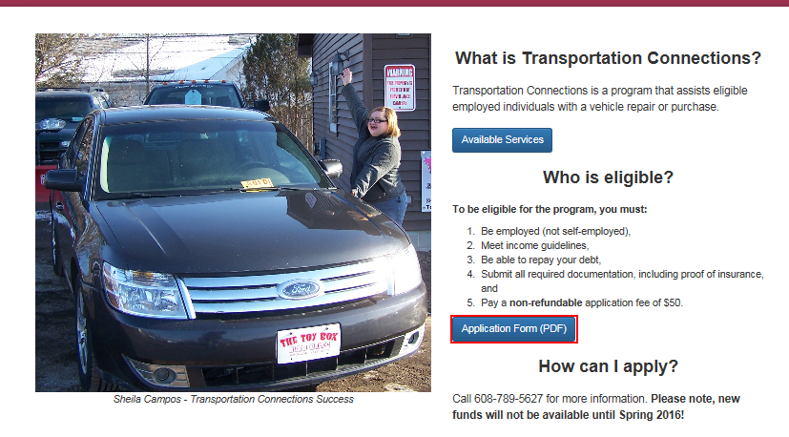

* 1. Remove Who is eligible and how can I apply.
  2. Combine text as one section.
  3. Below text put the two “links below.
     1. Change Available services to “Requirements”
     2. Remove (PDF)

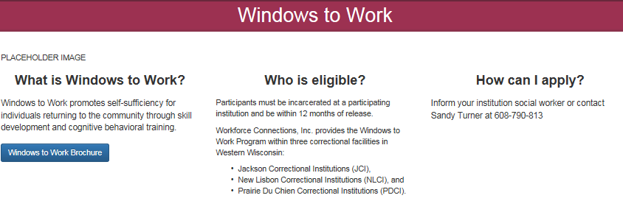

1. Windows to Work promotes self-sufficiency for individuals returning to the community through skill development and cognitive behavioral training. Services are available within the following correctional facilities in western Wisconsin:

* Jackson Correctional Institution
* New Lisbon Correctional Institution
* Prairie Du Chien Correctional Institution

1. Combine next 2 columns: For eligibility and to apply:

Participants must be incarcerated at a participating institution and be within 12 months of release. For more information inform your institution social worker or contact Sandy Turner at 1-608-790-8137.



We talked about combining this as one page for both adult and dislocated worker. I’m guessing this page is still under construction?

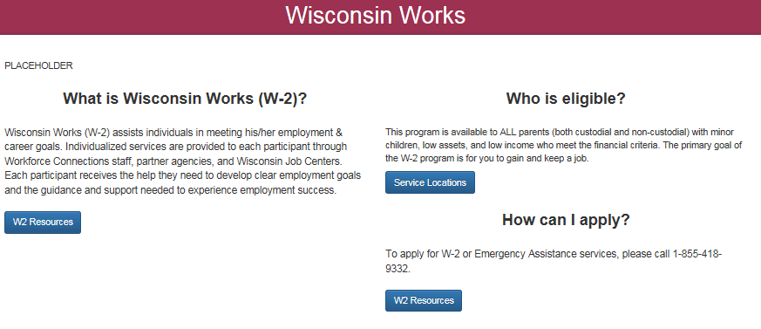

1. 1st column text:
2. Combine 2nd column into one. For eligibility and to apply:

Wisconsin Works is available to ALL parents (both custodial and non-custodial) with minor children, low assets, and low income who meet the financial criteria. The primary goal of the W-2 program is for participants to receive skills and maintain employment. To apply for W-2 services, please call 1-855-418-9332.

1. Remove service locations link.
2. Below text add links, like you did for FSET.
3. Remove subheadings: printable forms, application information, job search tools, verification tools, activity log, grievance procedures. Redundant – link titles should give them enough information.
4. Remove how to apply tab.
5. Combine W2 overview, who is eligible, W2 support services in one module entitled “W-2 Overview” to include the below text:

**What is Wisconsin works (W-2)?**

The W-2 and related programs are funded through the State of Wisconsin Department of Children and Families using Temporary Aid to Needy Families (TANF) funds.

Wisconsin Works (W-2) assists individuals in meeting his/her employment & career goals. Individualized services are provided to each participant through Workforce Connections staff, partner agencies, and Wisconsin Job Centers. Each participant receives the help he/she needs to develop clear employment goals and the guidance and support needed to experience employment success.

Workforce Connections Inc. is contracted with the state of Wisconsin Department of Children and Families to operate Wisconsin Works (W-2) programs in Buffalo, Crawford, Jackson, La Crosse, Monroe, Pepin, Trempealeau and Vernon Counties.

The goal of Wisconsin Works (W-2) is to provide necessary and appropriate services to prepare individuals to work, and to obtain and maintain viable, self-sustaining employment, which will promote economic growth. W-2 is designed to ensure that everyone in Wisconsin shares in our economic opportunities.

**Who is eligible?**

This program is available to ALL parents (both custodial and non-custodial) with minor children, low assets, and low income who meet the financial criteria. The primary goal of the W-2 program is for you to gain and keep a job. There are different levels of placement within W-2. Each is tied to your current ability for work and retraining a job. Based on your situation, skills, resources, barriers to employment, and eligibility, you will be offered a specific placement in W-2.

You will be assigned an Employment Coordinator who will work with you to:

1. Hone your skills on finding job leads
2. Learn and master the application and interview processes
3. Develop personal budgets and financial plans
4. Refer you to other services
5. Get you back in the workforce
6. Work with you and your new employer on job retention

**W-2 Support Services:**

Wisconsin Works (W2) provides support services to families and individuals who need assistance in rejoining the workforce. The following support services are available:

1. Child Care - Families may apply for help with establishing and paying for child care.
2. Transportation - W-2 participants may receive help in finding and paying for transportation to and from work.
3. Job Access Loans (JAL) - Short term, no interest loans may be available to assist workers in obtaining or retaining employment.
4. Other miscellaneous services based on your needs and eligibility.

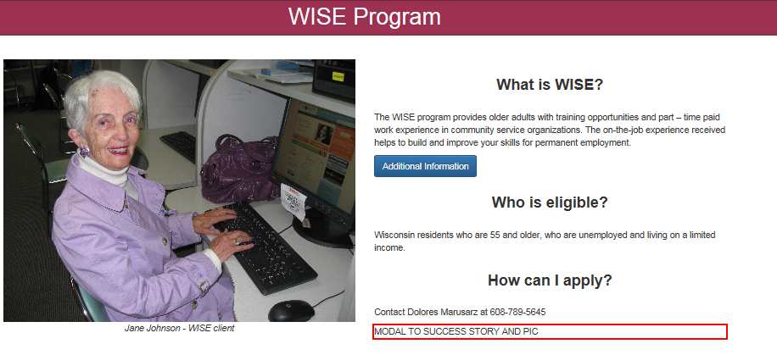

1. The WISE Program provides older adults, age 55 and older, with training and part-time, paid work experience in community service organizations. The on-the-job experience helps to develop and improve skills necessary for permanent employment.

Each participant receives individual job counseling and a comprehensive assessment from a specialist. Together, the job seeker and specialist prepare an individual employment plan to be used as a guide for finding appropriate job opportunities.

The Wisconsin Senior Employment (WISE) Program is the state-administered Senior Community Service Employment Program (SCSEP), authorized by Title V of the Older Americans Act, federally funded by a grant from the U.S. Department of Labor.

1. For eligibility and to apply:

Wisconsin residents who are 55 and older, unemployed, and living on a limited income may qualify. For additional information, call Dolores Marusarz at 1-608-789-5645.

1. No link button needed.

RESOURCE TAB:

1. Line up both columns of community resources and county websites.
2. Remove existing subheadings.
3. Instead call the bottom section: Career Opportunities.

Can you make Career Opportunities stand out on the page?

Then include job search links. Remove WDB, unless you know if we are required to include it. It does not pertain to our customers.

CAREERS TAB:

1. What can we do here to make this page more exciting?

Volunteers link:



1. Change button to read the same as it does on the Second Chance page.

Become a Connections Coach

1. Remove how to apply subheading
2. Remove “thank you for your interest in our Connections Coach (mentor) opportunity! Please click below for more information.
3. Text to read: (get rid of what is there now)

Please submit the application form to [workforceconnections@workforceconnections.org](mailto:workforceconnections@workforceconnections.org) or call the Connections Coordinator at 1-608-789-6094 for more information. We look forward to working with you!

STAFF LISTING:

Is this something that Brad can update as needed?

BOARD OF DIRECTORS:

Is this something Brad can update as needed?